In this assignment, the purpose is to use Newton’s Method, Modified Newton’s Method, and

Steffensen’s method (notated as -1, -2 and -3 within the following charts) to find solutions of Exercise

Set 2.4 Question 2 accurate to within 1e-5.

These root finding methods, gotten from *Numerical* *analysis* *tenth* *edition*, written by RICHARD L.

BURDEN, DOUGLAS J. FAIRES, ANNETTE M. BURDEN, (2014), the algorithm2.3 (page67) and algorithm2.6

(page88), were used to iterate values and find the approximated roots by following table.

The **stopping** **condition** for these iteration methods is **when** **|**𝒑𝒏 − 𝒑**|** **<** **TOL** **and** **TOL** **=** **1e-5.** For

Steffensen’s Method, adding an extra “x” in each side of each equation so that they were constructed as

g(x) = x. Apparently, the roots of (b) which are **-1.3343** is out of interval [-3, 2], so (b) is NOT convergence

in this specific interval and (a), (c) and (d) are convergence from the charts above.

Q(a): Stefensen’s Method is better, because it converges faster than other methods and it gets great

solution.

Q(b): Since all the method that were used could not get the root within the specific interval, (b) will NOT

be discussed in terms of these method.

Q©: Newton’s Method is better, because this method requires **less** **work**,

though all the method can cancel the error and get the solution at the exactly second step.

**Number:** **Q(a)** **Q(b)** **Q**_ **Q(d)**

**Interval:** **[0,** **1]** **[-3,** **-2]** **[3,** **4]** **[3,** **5]**

**Newton's** **Method** *0.73907* *-1.3343* *3.1416* *3.7331*

**solution** **Modified** **Newton's** **Method** *0.73909* *-1.3343* *3.1416* *3.7331*

**Steffensen's** **Method** *0.73910* *-3.0000* *3.1416* *3.5000*

*Same* *Same*

*question,* *question,*

*but* *but*

*different* *different*

*root* *finding* *root* *finding*

*methods* *methods*

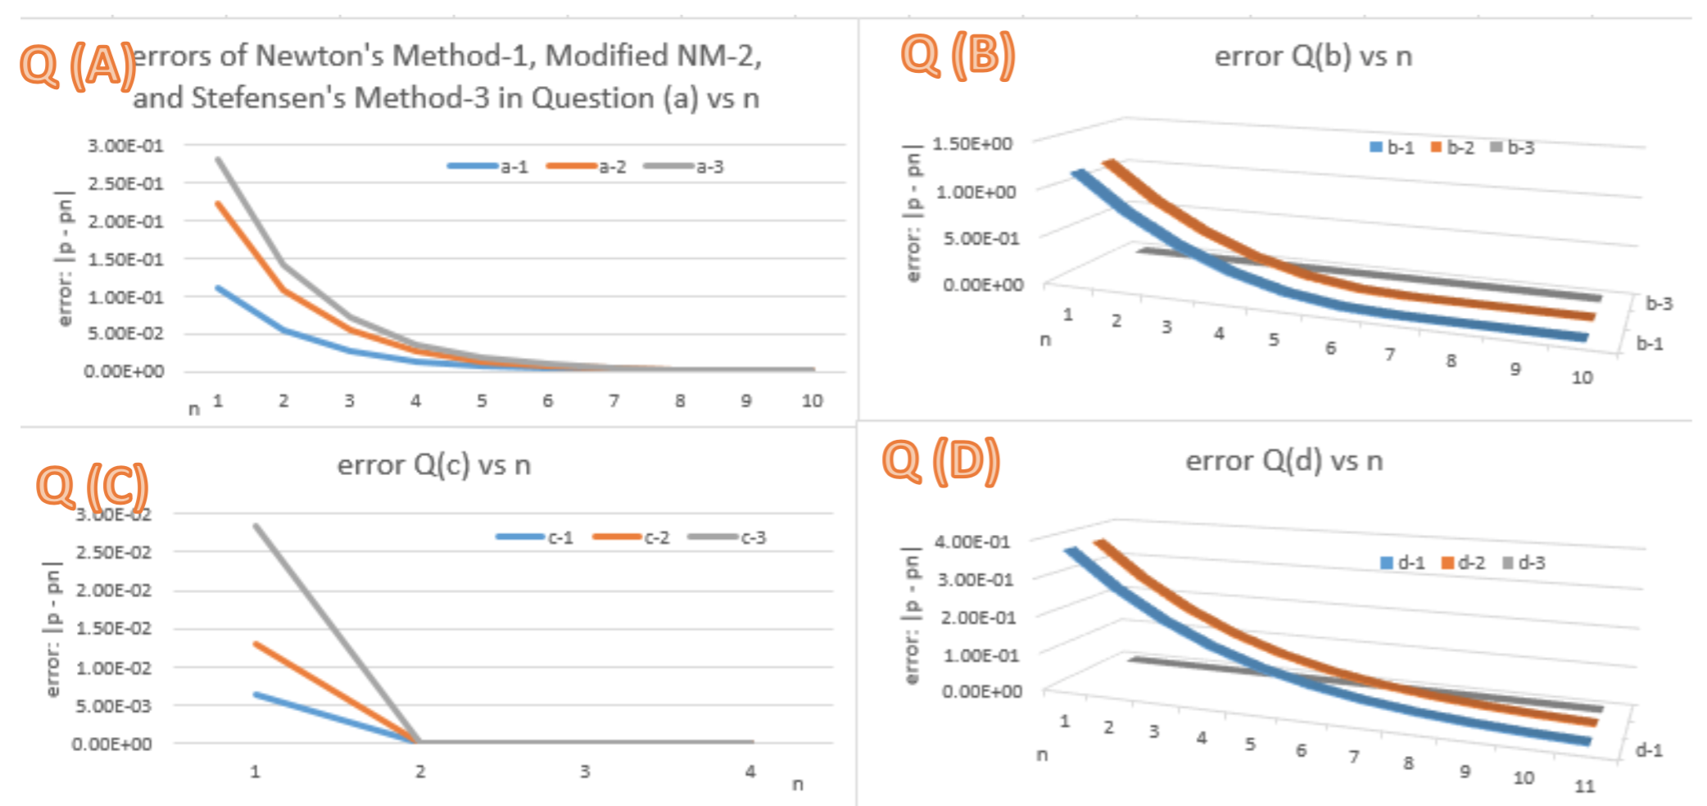

**Q (B)**

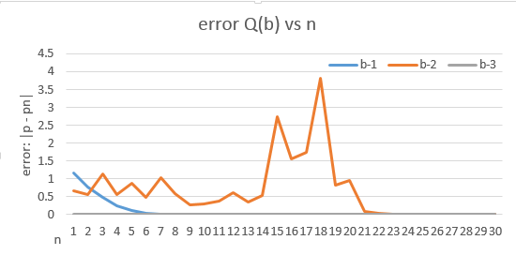

Differently, the error of Newton’s Method and Modified Newton’s Method are exactly the same (> 0).

Q(d): Stefensen’s Method is better. This method’s error is always zero (or close to zero)**.**